**e-Ethics System –** **Applicant User Guide**

**What is e-Ethics?**

The e-Ethics system is an online ethics application and reviewing system; the process must be completed in order to obtain ethical approval for research projects.

**Stage 1 – Application**

The applicant must complete the online application and submit for ethical review. Please note that the purpose of this form is to clearly explain the ethical considerations of the research proposed to be undertaken.

**Stage 2 – Ethical review**

The application will be ethically reviewed by the appropriate College or department Ethics Committee. The application may be referred back to the applicant for amendments at this stage.

**Stage 3 - Decision**

The applicant will be notified when the committee has reached a decision regarding the application.

|  |  |
| --- | --- |
| **Possible decision outcomes** | |
| Favourable | Application is granted ethical approval |
| Favourable with conditions | Application is granted ethical approval providing certain conditions, specified by the reviewer, are met. |
| Provisional | Application requires amendment and to be resubmitted for further review |
| Unfavourable | Application is rejected |

**Who should complete an e-Ethics application?**

An e-Ethics application must be submitted by all researchers (undergraduate, Masters students, PhD students and all staff). All research involving humans (either living or deceased), their data or tissue, or animals, should be ethically reviewed and receive a favourable opinion before work commences. Please use the following link to the framework

<http://www.exeter.ac.uk/cgr/researchethics/integrity/>

Applicants must wait for ethical approval **before** commencing any research projects. Ethical approval will not be given retrospectively.

**When should I complete an e-Ethics application?**

You should complete your e-Ethics application after you have discussed ethical issues with your research supervisor or research team. You are encouraged to consult your discipline or College Ethics Committee for advice at any stage prior to completing the application, especially for Track B applications.

**Where can I access the e-Ethics application system?**

You can access the e-Ethics application system via: <https://eethics.exeter.ac.uk/>

*Please note, to access the e-Ethics application system **you must be connected to the University Network**. This may mean you are connected to the UoE Network on campus or by using VPN when off campus. For further instructions about using VPN please consult the University webpages: <http://as.exeter.ac.uk/it/network/vpn/>.

|  |  |  |
| --- | --- | --- |
| **Key Points** | | |
| Mandatory | Denotes a mandatory field | This must be completed before you can save and submit an application |
| Help | Denotes a help textbox | Click on the Help icon for guidance on what is required for that particular field |
| **Saving your application** | Before saving an application, you **must** complete all mandatory fields on all tabs. Once you have completed all mandatory fields you can save the application and exit the system. The application will remain on your e-Ethics homepage until you next visit the page to update your application. | |
| **Submitting your application** | Before submitting an application, you **must** complete all mandatory fields on all tabs. Once you have completed all mandatory fields you can save the application and submit. Please note, by submitting an e-Ethics application you are confirming you will abide by the details given in the application. You are also confirming that if your proposed research should change, you will complete an amendment and resubmit the application for further review. | |

|  |  |  |  |  |  |  |  |  |
| --- | --- | --- | --- | --- | --- | --- | --- | --- |
| **User Guide Contents** | | | | | | | | |
| 1 | **Accessing the e-Ethics application form** | | | |  |  |  | p5 |
|  | 1.1 | How to access the system | | |  |  |  | p5 |
|  | 1.2 | Changing to other College Ethics Committees | | | | |  | p5 |
| 2 | **Start a new e-Ethics application** | | | |  |  |  | p5 |
|  | 2.1 | New Application | |  |  |  |  | p5 |
| 3 | **Summary tab** | |  |  |  |  |  | p5 |
|  | 3.1 | Title |  |  |  |  |  | p5 |
|  | 3.2 | Type of applicant | |  |  |  |  | p5 |
|  |  | 3.2.1 | Project Supervisor | |  |  |  | p5 |
|  | 3.3 | Selecting Campus | |  |  |  |  | p5 |
|  | 3.4 | Applicant name | |  |  |  |  | p5 |
|  | 3.5 | Applicant declaration | | |  |  |  | p5 |
|  | 3.6 | Externally Ethically Reviewed | | |  |  |  | P5 |
|  | 3.7 | Principal/Chief Investigator | | |  |  |  | P6 |
|  | 3.8 | Other Researchers/Collaborators | | | |  |  | P6 |
|  | 3.9 | Estimated Start Date | | |  |  |  | p6 |
|  | 3.10 | Externally funded projects | | |  |  |  | p6 |
|  |  | 3.10.1 Funding | | |  |  |  | p6 |
|  | 3.11 | Project Summary | |  |  |  |  | p6 |
|  | 3.12 | Next tab |  |  |  |  |  | p6 |
| 4 | **Location Tab** | |  |  |  |  |  | p6 |
|  | 4.1 | Location details | |  |  |  |  | p6 |
|  | 4.2 | Postcode |  |  |  |  |  | p6 |
|  | 4.3 | URLs |  |  |  |  |  | p6 |
|  | 4.4 | Next tab |  |  |  |  |  | P7 |
| 5 | **Details** |  |  |  |  |  |  | p7 |
|  | 5.1 | Links to previous applications | | |  |  |  | p7 |
|  | 5.2 | Has your project been scientifically/peer reviewed | | |  |  |  | p7 |
|  | 5.3 | What does your project involve? | | | |  |  | p7 |
|  |  | 5.2.1 | DNA |  |  |  |  | p7 |
|  | 5.4 | Track type | |  |  |  |  | p7 |
|  | 5.5 | Next tab |  |  |  |  |  | p7 |
| 6 | **Human/Animal Samples** |  |  |  |  |  |  | p7 |
|  | 6.1 | If YES |  |  |  |  |  | p7 |
|  | 6.2 | If NO |  |  |  |  |  | p7 |
| 7 | **Questions** | |  |  |  |  |  | p7 |
|  | 7.1 | Variations of questions | | |  |  |  | p7 |
|  |  | 7.1.1 | Human |  |  |  |  | P8 |
|  |  | 7.1.2 | Animal |  |  |  |  | p8 |
|  |  | 7.1.3 | Both |  |  |  |  | p8 |
|  |  | 7.1.4 | Neither |  |  |  |  | p8 |
|  | 7.2 | Next tab |  |  |  |  |  | p9 |
| 8 | **Statement** | |  |  |  |  |  | p9 |
|  | 8.1 | Variations of statements | | |  |  |  | p9 |
|  | 8.2 | Table listing variations | | |  |  |  | p9 |
|  | 8.3 | Next tab |  |  |  |  |  | p9 |
| 9 | **Upload Files** | |  |  |  |  |  | p9 |
|  | 9.1 | Upload function | |  |  |  |  | p9 |
|  | 9.2 | Type of file | |  |  |  |  | p9 |
|  | 9.3 | Reference | |  |  |  |  | p9 |
|  | 9.4 | Version |  |  |  |  |  | p9 |
|  | 9.5 | Date |  |  |  |  |  | p9 |
|  | 9.6 | Uploading | |  |  |  |  | p9 |
|  | 9.7 | Viewing attachments | | |  |  |  | p10 |
|  | 9.8 | Deleting attachments | | |  |  |  | p10 |
| 10 | **Comments** | |  |  |  |  |  | p10 |
|  | 10.1 | Comment function | |  |  |  |  | p10 |
| 11 | **Save and Close** | |  |  |  |  |  | p10 |
|  | 11.1 | Saving the application | | |  |  |  | p10 |
|  | 11.2 | Unable to Save | |  |  |  |  | p10 |
|  | 11.3 | Closing |  |  |  |  |  | p11 |
| 12 | **Submit** |  |  |  |  |  |  | p11 |
|  | 12.1 | Current application tab | | |  |  |  | p11 |
|  | 12.2 | Editing applications | |  |  |  |  | p11 |
|  | 12.3 | Submitting applications | | |  |  |  | p11 |
|  | 12.4 | Status |  |  |  |  |  | p11 |
|  | 12.5 | Notification (Delivery email) | |  |  |  |  | p12 |
| 13 | **Decision** |  | |  |  |  |  | p12 |
|  | 13.1 | Outcome notification | |  |  |  |  | p12 |
|  | 13.2 | Possible outcomes | |  |  |  |  | p12 |
|  | 13.3 | Applicant actions | |  |  |  |  | p12 |
| 14 | **Amendments** | |  |  |  |  |  | p13 |
|  | 14.1 | Amendments | |  |  |  |  | p13 |
|  |  | 14.1.1 | Feedback types | |  |  |  | p13 |
|  |  | 14.1.2 | Feedback types (student applicant) | | | |  | p13 |
|  |  | 14.1.3 | Feedback types (staff applicant) | | | |  | p13 |
|  | 14.2 | Amendments to application outcomes of ‘Favourable’ or ‘Favourable with conditions’ | | | | |  | p13 |
|  | 14.3 | Amendments to application outcomes of ‘Provisional’ or ‘Unfavourable’ | | | | |  | p13 |
|  | 14.4 | Amendments to applications that have not been authorised to go forward for ethical approval | | | | |  | p13 |
|  |  |  | | | | |  |  |

**Step-by-step guide to an e-Ethics application**

**1. Accessing the e-Ethics application form**

**1.1** To access the application form use the web address <https://eethics.exeter.ac.uk/> As you are connected to the University Network, the system will automatically recognise your username and divert you to the correct homepage.

**1.2** To override the automatic routing and submit your e-Ethics application to another discipline or College Ethics Committee, use the ‘Different College’ link and select the required Committee.

**2. Start a new e-Ethics application**

**2.1** Click on the ‘New Application’ tab to begin your ethics application and enter the details relating to your research project.

**3. Summary tab**

**3.1 Title** – Please enter the title of the project you are seeking ethical approval for.

**3.2 Type** – Please select either staff or student (UG= Undergraduate programme, PGT = Post Graduate taught programme, PGR= Post Graduate research programme) depending the type of project you are submitting.

**3.2.1 Project Supervisor** – If you are submitting a student e-Ethics application, you will need to provide the name and email address of your Project Supervisor. Please note, the system has an auto-look up function which can be used once you start typing. Begin by typing the Project Supervisor’s surname; the name and email will automatically fill the boxes provided once you have selected the correct name. You can override this function by free typing the name and email.

**3.3 Campus** –The system will automatically allocate you a ‘Campus’ option based on your University of Exeter username. If you need to change the campus automatically allocated to you, please select a new option from the drop down menu.

**3.4 Applicant**- Your name should automatically appear in the ‘Applicant’ field if you are accessing the system using your University username. This will automatically link your application to your University of Exeter email address; all correspondence sent out from the e-Ethics system will be sent to this address.

**3.5 Applicant Declaration** – Confirm you have read the University of Exeter’s [Code of Good Practice in the Conduct of Research](http://www.exeter.ac.uk/research/inspiring/about/goodpractice/) by selecting the tick-box option. It is mandatory for all staff and students who conduct research under the auspices of the University of Exeter to abide by this Code.

**3.6 Has your project been externally ethically reviewed**– Select yes or no.

**3.6.1 Please provide further information–** If yes, please provide details.

**3.7 Principal/Chief Investigator** (for Staff applications only)– You need to provide the name and email address of the Principle or Chief Investigator. Depending on your discipline, you may use either terminology. In some cases the applicant themselves will be the Principal or Chief Investigator; in this case, select the ‘Same as applicant’ tick box. Help text is provided to explain the role of the Principal/Chief Investigator.

**3.8 Other Researchers/Collaborators –** Enter the name and email address of other researchers and collaborators who are involved in the project. You can utilise the automatic look-up function by typing the first letters of their surname and selecting the correct option. You can add external collaborators by free typing the name and email address. You must select the ‘Add to application’ button to add a collaborators name to your application. To delete a collaborator from your application, just click on the link to their name and email.

**3.9 Estimated Start Date –** Use the calendar function to select the estimated start date of your project. Then enter the proposed length of your project in the ‘Duration in months’ field.

**3.10 Is the project externally funded** – Select yes or no depending on whether you have received external funding.

**3.10.1 Funding –** If you have answered yes to the question ‘**Is the project externally funded’** provide further details in this field.

**3.11 Summary of Project –** Provide a lay summary of your project. Refer to the help text for guidance on what this should include. The word count is displayed in both words and characters and will limit your total to whichever comes sooner – the remaining total is displayed under the text field. Please note, the word limits are an indication of the level of detail the Committee would like to see.

**3.12** To proceed to the next stage of your application please select the ‘**Next**’ button or the **‘Location’** tab on the application toolbar.

**4. Location Tab**

**4.1 Please provide details of locations –** Refer to the help Helptext for guidance on what to include in this field. The text field will expand as your type. If you find it easier, you can compose your answer in a word document and copy and paste it across.

**4.2 Postcode and Description –** Enter a postcode or zip code into the postcode field. A Google map with a pin dropped on your location will appear. Provide a brief description or reference for this location in the following ‘Description’ field.

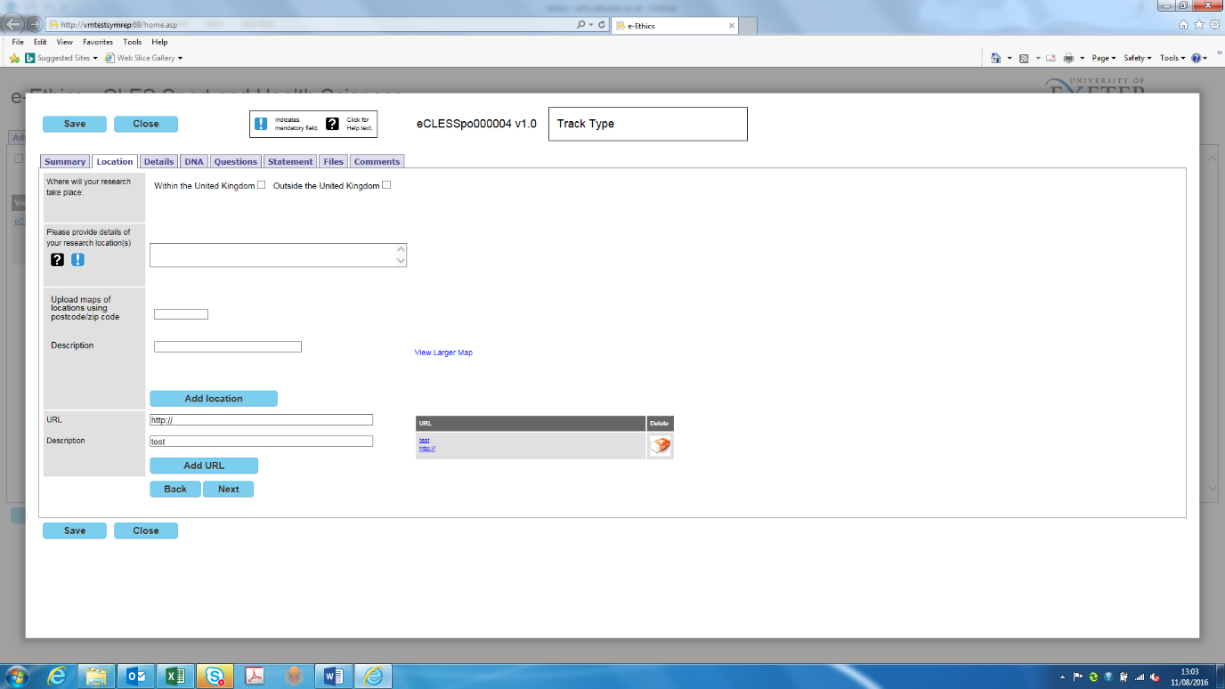**4.3 URL and Description –** Add relevant URLs to your application by entering a URL and description and then clicking ‘Add URL’. To add multiple URLs simply repeat this step. Once the URL is added an additional box will appear

To delete URLs from your application, select the Delete icon.

**4.4** To proceed to the next stage of your application please click the **‘Next’** button or the **‘Details’** tab on the application toolbar

**5. Details**

**5.1 Application linked to a previous application –** Please select either ‘yes’ or ‘no’ depending on whether your application is linked to a previous application.

**5.1.1** **Reference:**  If yes, enter the application reference number and the name of the Principal/Chief Investigator listed on the previous application.

**5.2 Has your project been scientifically/peer reviewed by any of the following** – Select one of the three options. To provide details of external peer review add the relevant documents to your application using the ‘Files’ tab on the application toolbar. You can upload files from here.

**5.2.1 Please explain why your project has not been reviewed –** If no, provide details why this has not been the case and whether this is appropriate for your project.

**5.3 Does your project involve –** Refer to the help Help text for guidance on completing this field.

**5.3.1 Human/Animal Samples -** If you select either Human, Animal or Both an additional field will appear asking whether the project involves Human/Animal Samples. Refer to the help Help text for guidance on what this may include. If you select ‘**yes**’ you will be required to complete questions on the Human/Animal Samples tab. If you select ‘**no**’, you will not have to complete the Human/Animal Samples tab and will move to the next stage.

**5.4 Track type –** Refer to the help Help text for guidance on whether your project is track A or B.

**5.5** To proceed to the next stage of your application please click the **‘Next’** button or the **‘Human/Animal Samples’** tab on the application toolbar

**6. Human/Animal Samples**

**6.1** If you selected ‘**yes**’ to the question ‘Does this study involve Human or Animal samples?’ you are required to complete the questions relevant to your project. If you selected ‘**no**’ then click on the ‘next’ button or the ‘Questions’ tab on the application toolbar to proceed to the next stage of the application. (If you selected ‘**no**’, please move to section 7 of the e-Ethics user guide.)

**6.2** After completing the applicable fields proceed to the next stage of your application by clicking the ‘Next’ button or the ‘Questions’ tab on the application toolbar. Please use the help Help text for more information.

**7. Questions**

**7.1** Depending on the answers you have selected previously in your application you will be required to answer the following set of questions:

**7.1.1 Humans –** If your project involves ‘Humans’ you will be required to complete a series of multiple choice questions, under the headings ‘**Communication and Consent**’, ‘**Possible Harms**’ and ‘**Vulnerable Groups**’. The answers you provide here, along with the ethics statement on the following tab, will help the Ethics Committee determine whether you have fully considered the ethical implications of your project proposal.

Please note, some questions may not be applicable to your project, in which case please select ‘N/A’.

In some instances, depending on your answers, you may be required to contact the University of Exeter’s Research Ethics and Governance Manager to discuss alternate ethical review processes which may be required. You will be instructed when and how to do this by the e-Ethics system. If your application is a Track A, depending on your answers, this may trigger the system to change your application to a track B if they are considered to be at a higher risk and you will be notified by a green message at the top of the page and also a box will appear.

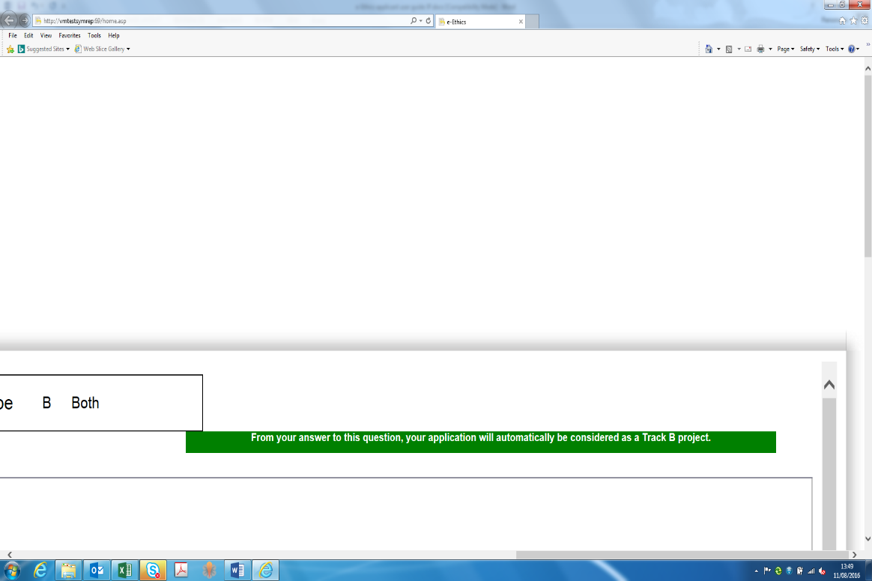

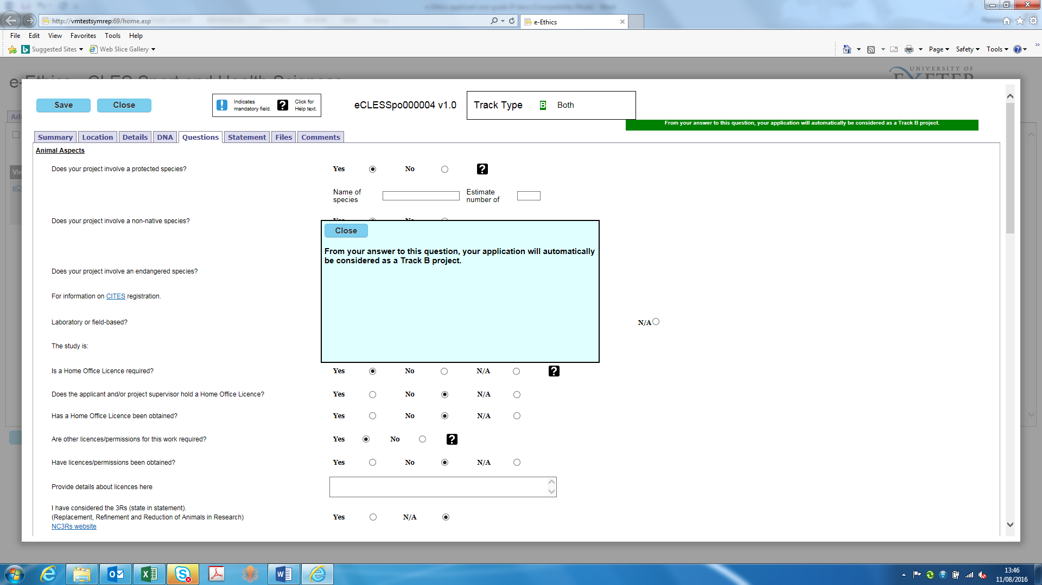

**7.1.2 Animals –** If your project involves ‘Animals’ you will be required to complete a series of multiple choice and written questions. Refer to help Help text for guidance on specific questions. The answers you provide here, along with the ethics statement on the following tab, will help the Ethics Committee determine whether you have fully considered the ethical implications of your project proposal.

Depending on your answers to the questions it may be necessary to contact Senior Lab Managers, your Project Supervisor or the [University’s Research Ethics and Governance Manager](mailto:ethics@exeter.ac.uk?Subject=Non-invasive%20advise) for further advice on the severity of protocols and the types of approval/licences which may be required.

**7.1.3 Both –** If your project involves both animals and humans you will be required to complete both sets of questions.

**7.1.4 Neither** – If your project involves none of the above, you will not be required to complete any questions on the ‘Questions’ tab. However, you should still provide details of your research method and address any ethical implications which arise from the proposed work as part of the ‘Statement’ tab.

**7.2** After completing the applicable questions, proceed to the next stage of your application by clicking the **‘Next’** button or the **‘Statement’** tab on the application toolbar.

**8. Statement**

**8.1** Depending on the answers you have selected elsewhere in this application you will be required to provide a range a written statements, expanding on the features of your project application and addressing the ethical implications which arise from the proposed work.

**8.2** After completing the applicable statement(s), proceed to the next stage of your application by clicking the **‘Next’** button or the **‘Upload’** tab on the application toolbar.

**9. Upload Files**

**9.1 Upload -** You can upload files to accompany your application using the ‘Upload’ function on the Files’ tab. Select ‘Upload’ and click on the ‘browse’ button to select the required file.

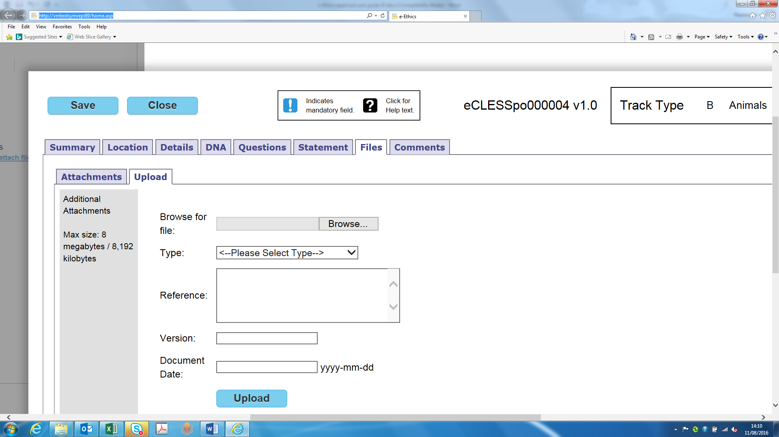

**9.2 Type –** Select the type of file you are attaching to the application from the drop down menu

**9.3 Reference** – Give the attachment a reference which will demonstrate to the Ethics Committee what its purpose or role is in relation to your project

**9.4 Version** – Provide the attachment with a version number. This can help track amendments you may make to attachments both during the ethical review process and duration of your project.

**9.5 Document date** – Select a date related to the curation or issuing of the document

**9.6 Upload the file** – Upload the file by selecting the blue ‘Upload’ button

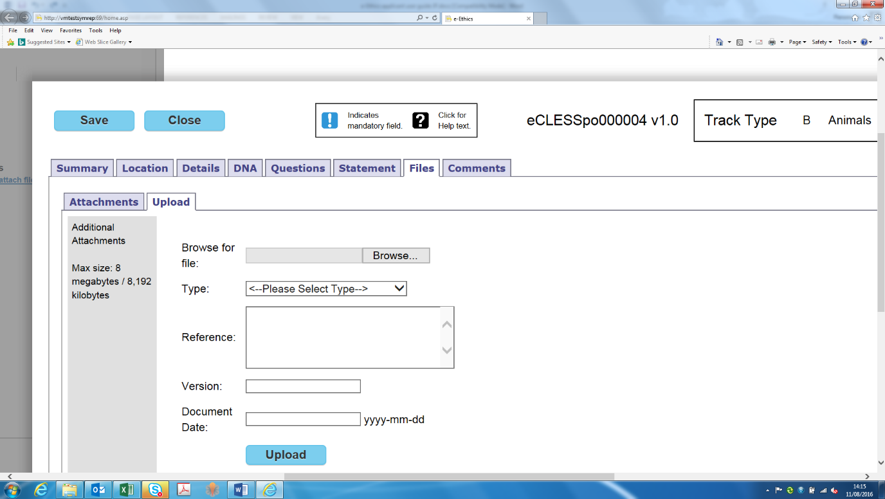

**9.7 View attachments** – View the files you have attached to your application by selecting the ‘Attachments’ tab. The list of attached files will be listed here.

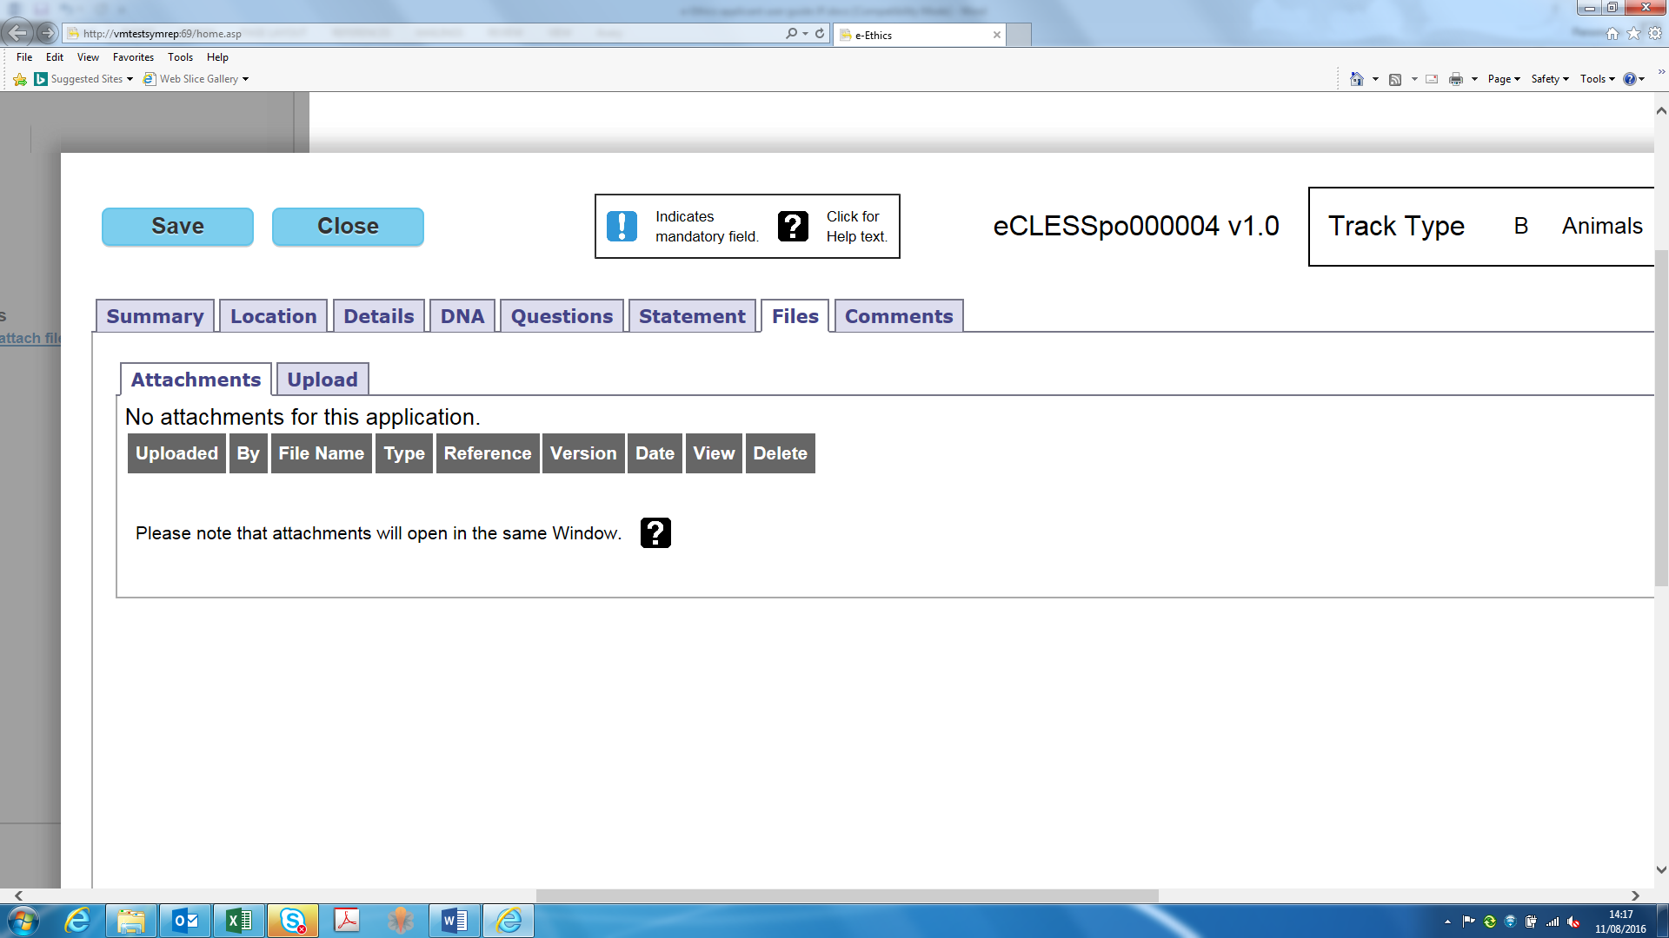

**9.8 Delete attachments** – Attachments can be deleted from the application by clicking the ‘Delete’ button in the far right column of each respective attachment

**10. Comments**

**10.1** The comments tab allows the applicant to view feedback from their project supervisor, the Chief/Principal Investigator, the application reviewer or the system administrator. This function enables users to record their feedback within the system without using external emails. By clicking on the ‘Add’ tab applicants can respond and add a comment.

You can also use the comment box whilst viewing your application to respond to feedback.

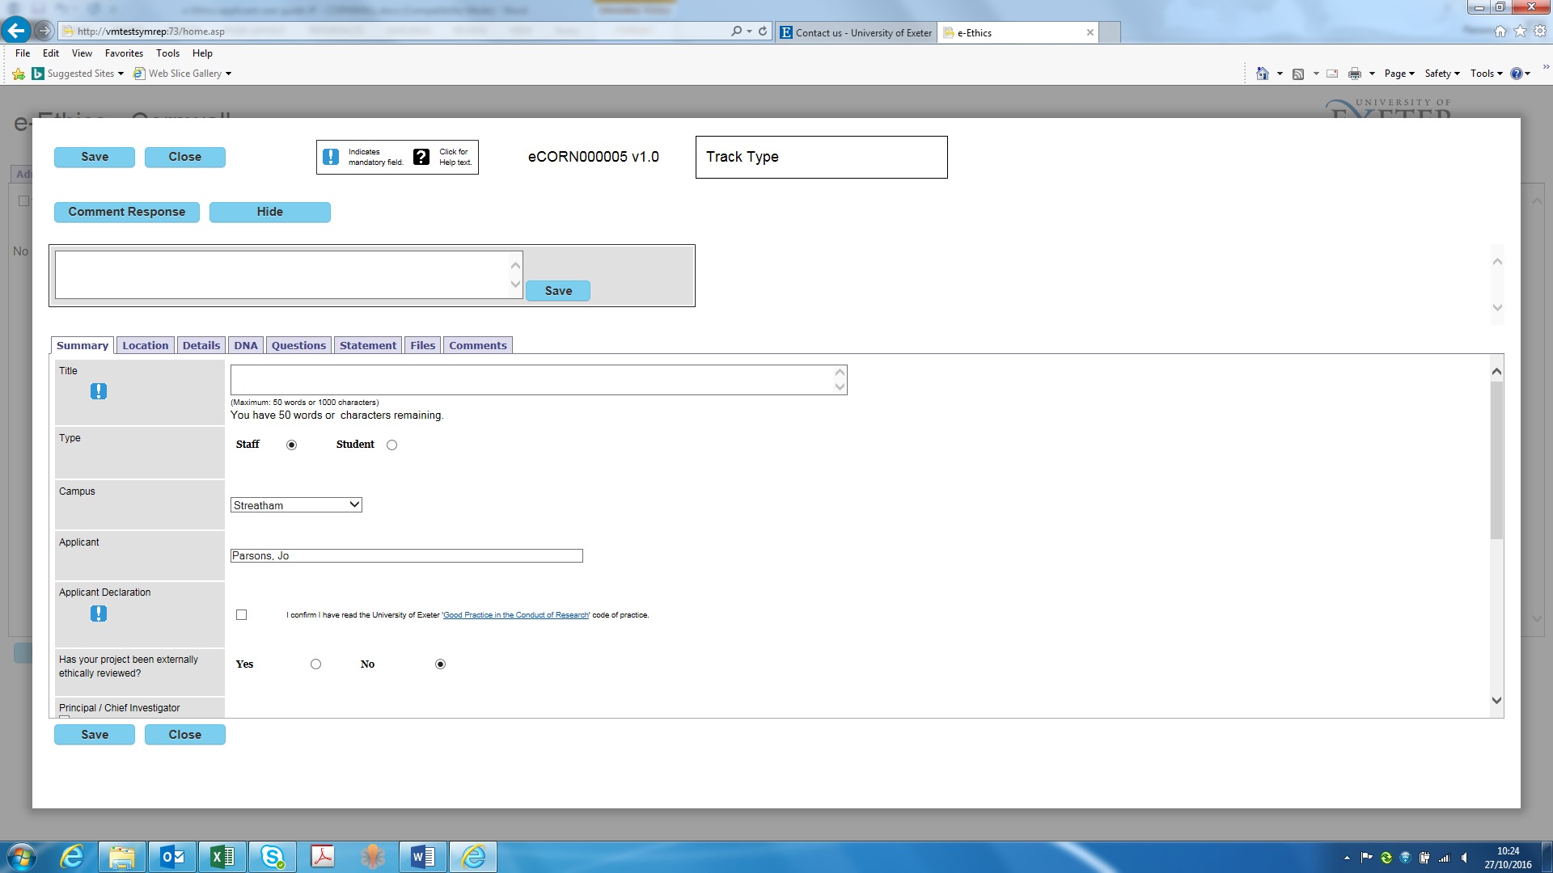

**11. Save and Close**

**11.1 Save** – To save your completed application, click the blue ‘Save’ button, displayed either at the top or bottom of the screen. Once the application has been successfully saved to the system, a green notification bar will appear in the top left corner stating ‘Saved’.

**11.2 Unable to Save** – If you try to save your application without completing all mandatory fields, the system will generate a pop-up window notifying you of the remaining fields yet to be completed. Press ‘OK’, complete the remaining mandatory fields as required and repeat the ‘Save’ process. Please note, there may be uncompleted mandatory fields on multiple tabs.

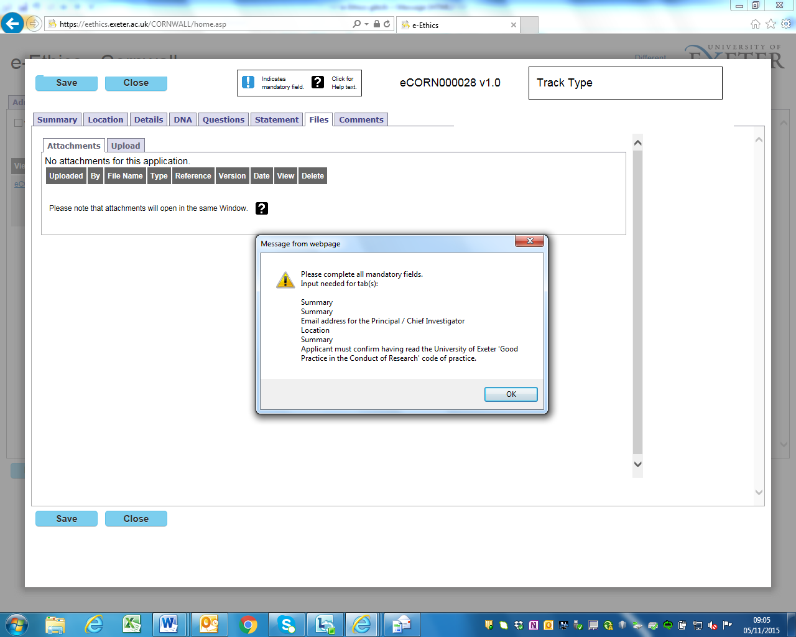

**11.3 Close -** You can exit your application and return to your Homepage by selecting the blue ‘Close’ button. !Please make sure you have saved your application or this will be lost!

**12. Submit**

**12.1 Current Application(s) –** Once you have returned to your Homepage, the application you have just completed will be listed under ‘Current Applications’. This dashboard will show you the following details:

- The application ID number

- Application title

- The current status of the application

- The actions available to the applicant

- Specific features of the application (audit trail, comments, attached files)

- Printable versions of your application. Note, the ‘Pack’ option will enable you to print the application complete with versions of the attached files. This is contrast to the ‘App’ option which is basically a printed version of the application’s screen shots

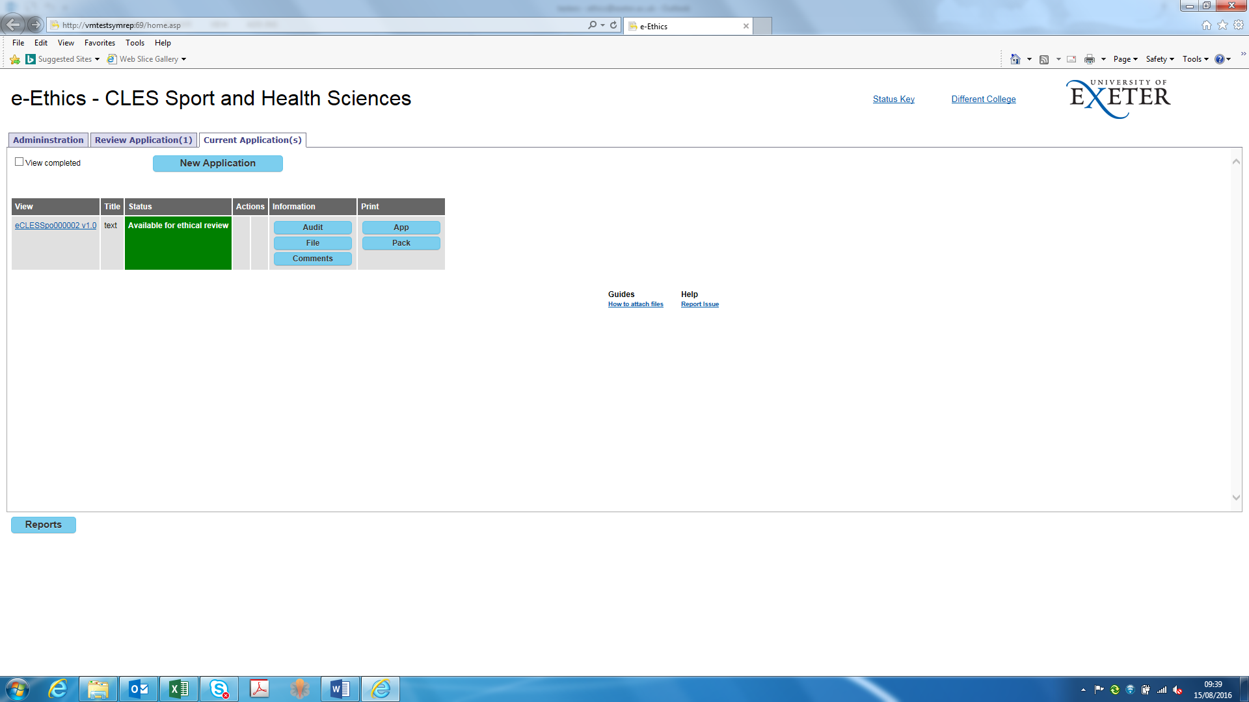

**12.2 Edit application –** To amend your application before submitting, click on the application ID number in the ‘View’ column. Remember to ‘Save’ and ‘Close’ the application after making your amendments as shown above.

**12.3 Submit –** To submit your application, click the ‘Submit’ button in the ‘Actions’ column. A window will then appear confirming you are ready to submit. If you are happy for your application to be submitted for ethical review by your Ethics Committee, click OK.

**12.4 Status change –** You will now notice your application status changed from ‘in progress’ to ‘submitted for approval’.

**12.5 Notification** – You will now receive an email to your University of Exeter email address confirming the submission of your application. Note, submitting your e-Ethics application does **NOT** represent ethical approval: You must not proceed with your programme of work until after you have received written confirmation from your Ethics Committee notifying you your application has been approved.

Please note that if you have submitted as a student your application will initially be sent to your supervisor for authorising your application to be put forward for ethical review and only if authorised by the supervisor, will the application be submitted for Ethical approval. If you are a staff member but not the PI/CI then your application will initially be sent to the PI/CI to be put forward for Ethical review and only if authorised by the PI/CI will the application be submitted for Ethical approval. If your supervisor/or PI/CI does not approve the application, the relevant amendments will have to be made and resubmitted to the supervisor or PI/CI. Please see section 14. Amendments.

**13. Decision**

**13.1** Once the Ethics Committee/Reviewer has made a decision based on your e-Ethics application you will be notified by email.

**13.2 Possible outcomes** – The possible outcomes you will receive are:

|  |  |
| --- | --- |
| **Possible outcomes** | |
| Favourable | Application is granted ethical approval |
| Favourable with conditions | Application is granted ethical approval providing certain conditions, specified by the reviewer, are met. |
| Provisional | Application requires amendment and to be resubmitted for further review |
| Unfavourable | Application is rejected |

***Please note; by clicking on the ‘PDF’ button on your dashboard you can download your outcome decision letter.***

‘To retrieve your PDF outcome letter please view your application by ticking ‘view completed’ and within the information column of your dashboard please click on the PDF button’

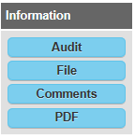

**13.3 Next steps –** Depending on the outcome of your decision you may be required to complete additional steps before you start your programme of work. This will be clarified in your decision email from the Ethics Committee

**14. Amendments**

**14.1** Once you have submitted your application, you may receive the following feedback which will require amending your application

**14.1.1 Supervisor, PI/CI amendments, reviewer feedback –** Once submitted for approval, your application may be referred back for amendment.

**14.1.2 Student application feedback** - If you are a student applicant, this feedback may come from your Project Supervisor or from the Ethics Committee directly. You will be notified by email that you are required to make an amendment and the details of the specific feedback

**14.1.3 Staff applicant feedback -** If you are a staff applicant, this feedback may come from the CI/PI or the Ethics Committee directly. You will be notified by email that you are required to make an amendment and the details of the specific feedback

**14.2 Amendments** **to applications submitted and received ‘Favourable’ or ‘Favourable with conditions’ outcome** – To amend an application at a later date that has already received a favourable outcome, access the e-Ethics system and view the ‘Current application(s)’ tab, click on ‘view completed’ box in the top left of the screen and select the relevant application. Click the ‘Amendment’ button in the Actions column of the dashboard. From here, provide the additional information required or as suggested from feedback. You are able to add additional files using the Upload tab. Click ‘Save’ and once you have returned to the dashboard, click ‘Submit’. You will receive an email from the system confirming your application has been submitted.

**14.3** **Amendments to applications submitted with ‘Provisional’ or ‘Unfavourable’ outcome** – to amend and application which has not received approval by the Ethical Review board, firstly access the e-Ethics system and view the ‘Current application(s) tab. Click on the application ID number in the ‘View’ column and edit the application. Remember to ‘Save’ and ‘Close’ the application after making your amendments as shown above. As previously you will have to press the submit button and go through the process again. Your application will be given a different version number.

**14.4** **Amendments to student/staff applications which have been declined by their supervisor or PI/CI to go forward for ethical approval**– Student or staff member will need to amend their application by firstly accessing the e-Ethics system and view the ‘Current application(s) tab. Click on the application ID number in the ‘View’ column and edit the application. Remember to ‘Save’ and ‘Close’ the application after making your amendments as shown above. As previously you will have to press the submit button and go through the process again. Your application will be given a different version number.